
English Composition and Reading I
(INGL 3201)
Master Course Syllabus, Fall 2015
University of Puerto Rico, Mayagüez Campus
Faculty of Arts & Sciences – Department of English
Instructor: Laura Coral García de la Noceda Vázquez

GENERAL INFORMATION

Alpha-numeric Codification: INGL 3201 Office: Chardón Building – 013
Title: English Composition and Reading I Office Hours: Mondays and Wednesdays
Number of Credits: Three (3) (2:00p.m. to 3:30p.m.) or by appointment
Contact Period: 3 hours of lecture per week Email: laura.garcia3@upr.edu
Non-Contact Period: 6 hours (2 hours/contact hour) Facebook Group: Ingl3201- 051
Class Schedule and Location: English Composition and Reading I
Monday/Wednesday/Friday in Chardón 125 Mailbox: Chardón Building – Room 323
051 (11:30am to 12:20pm)
061 (12:30am to 1:20pm)

Disclaimer: This syllabus is subject to change and may be amended during the course of the semester in order to correct unintended errors, comply with the established course objectives, and/or respond to contingencies.

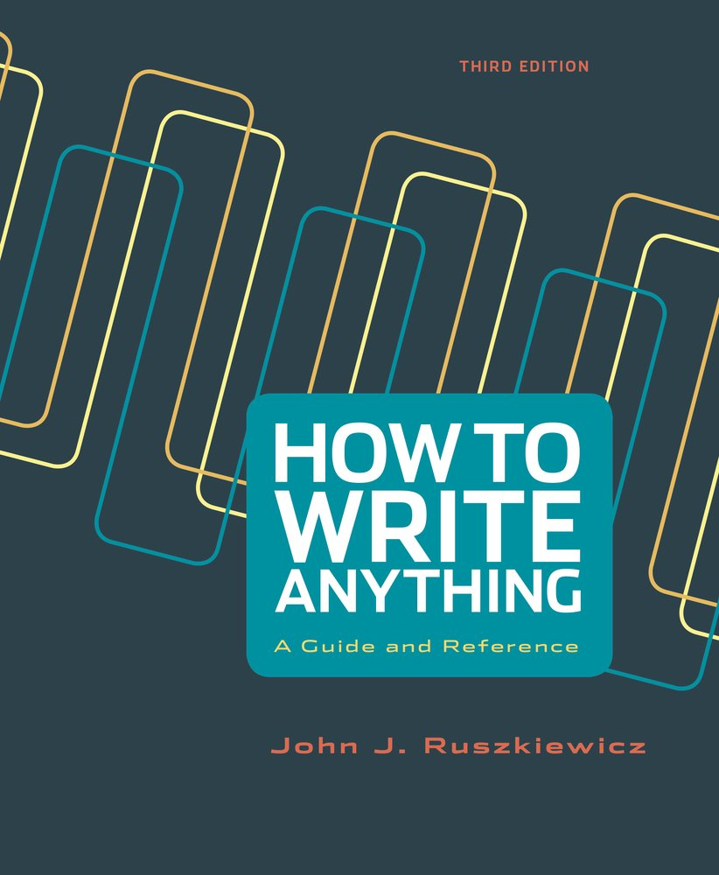

“It is the goal of How to Write Anything to guide college writers through…complex choices for their most common academic and professional assignments. In doing so, it lays out key strategies to follow in any situation that requires purposeful writing”
~John J. Ruszkiewicz (vii)
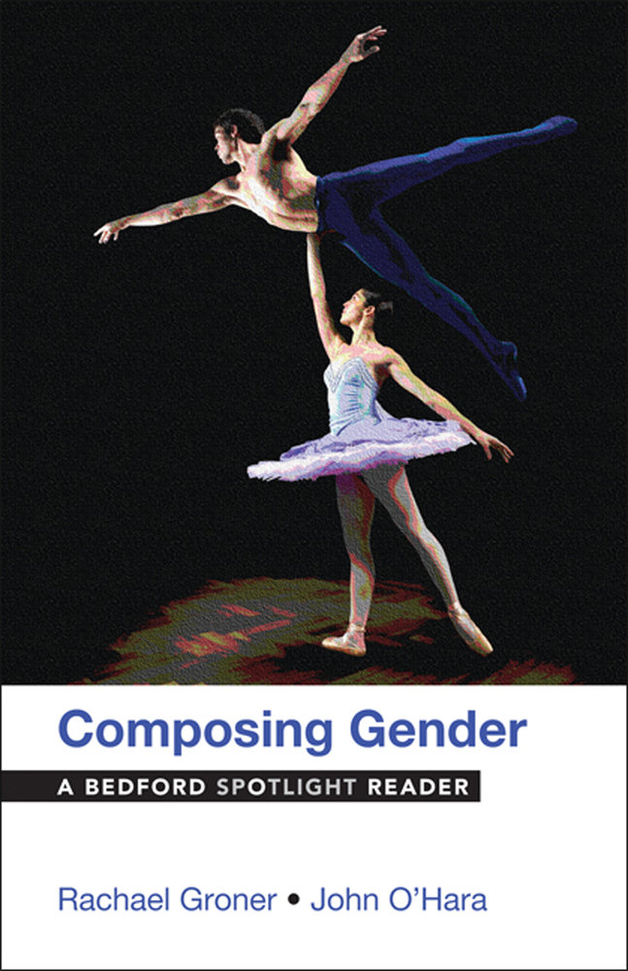
“Like with language, gender does not just reflect reality but shapes it. Even our most routine acts (such as waking up and choosing or not to wear certain clothing or hairstyles) represent subtle choices having to do with performing gender.”
~Rachael Groner and John F. O’Hara (v)

OFFICIAL COURSE DESCRIPTION
Practice in writing compositions and making oral reports upon selected readings, including essays, short stories, poems, dramas and novels. Attention will be given as needed to grammar and idiomatic expressions.

Instructor’s Course Description
This course is designed to improve students’ writing, reading, speaking and listening abilities in English using content that is based on a variety of non-fiction texts. Attention will be given to increasing grammatical accuracy in the context of academic writing and research. The purpose is for students to build on their current knowledge so they can successfully use English.

PREREQUISITE
English Composition and Reading I (INGL 3201) is the third course of a sequence designed for entering students at the Mayagüez Campus of the University of Puerto Rico who have scored 470 to 569 on the College Board Entrance Examination, or who have passed Pre-Basic English or the exit exam for Pre-Basic English. Students who successfully pass INGL 3201 must pass INGL 3202 to satisfy University requirements. Only students who were enrolled in Basic English (INGL 3101 or 3102) in previous semesters should take this course.

COURSE OBJECTIVES
After completing INGL 3201, students should be capable of demonstrating the following skills and abilities in the area of writing:

Narrowing a topic
Writing a thesis statement
Providing supporting details for all general statements in their essays
Organizing the content of their own writing
Writing introductory, body, and concluding paragraphs
Demonstrating evidence of the ability to revise, edit and proofread their own work
Engaging in peer review
Working through a series of drafts, writing a well-organized and effective essay on a given topic and/or in response to a text
Writing a persuasive essay
Writing a basic research paper
Writing in formal academic style
Using MLA system of formatting
Using MLA system of documentation (including quotation, paraphrase, and summary methods) to avoid plagiarism
Evaluating and using library and/or information technologies (e.g. databases)
Applying basic English grammar within the context of their own writing
Writing a final exam in an assigned 2-hour time period in response to a prompt

After completing INGL 3201, students should be capable of demonstrating the following skills and abilities in the area of READING:
Analyzing and discussing texts
Stating an author’s intended meaning, purpose and point of view
Recognizing the organizational structure of selected texts
Identifying supporting evidence
After completing INGL 3201, students should be capable of demonstrating the following skills and abilities in the area of speaking:
Giving an oral presentation without reading from a script
In pairs or small groups, participating in open-ended, extended dialogues, using everyday English, about familiar/self-chosen topics or situations, as supported by class discussion of topics/themes, classroom reading, vocabulary development, and so on

INSTRUCTIONAL STRATEGIES
The following instructional strategies will be incorporated in this class:

Journal Writing
Mini-Lectures
In-Class Discussions in Small Groups and Collectively
Reading and Writing Workshops
Small Group Presentations
Peer Editing and Proofreading
Guided and Independent Research
Guest Speakers
Multimodal Presentations

Minimum or Required Resources Available
In this course, the instructor and students require routine access to computing facilities and the Internet, a digital projector, an overhead screen and speakers.

REQUIRED TEXTBOOKS

Groner, Rachel, and Frank F. O’Hara. Composing Gender: A Bedford Spotlight Reader. New York: Bedford/St. Martin’s, 2014. Print.

Ruszkiewicz, John J. How to Write Anything: A Guide and Reference. 3rd ed. New York: Bedford/St. Martin’s, 2015. Print.

PURCHASING AND ACCESSING THE REQUIRED TEXTS

All students should have a copy of the two required texts for the class by the second day of class. These two texts are sold in a package for $66.90 (tax not included). If you receive the Pell Grant and it has not yet arrived, the book store offers a line of credit that allows you to purchase the book until your grant funding arrives. To take advantage of this possibility, you must bring your ID and the bill for your registration costs. When you receive the grant check, you will repay your debt to the bookstore.

If you do not receive the Pell Grant and cannot afford to purchase the text, you must make photocopies of all required readings from the copies of the book available on the shelves and/or on reserve in the library. There are five copies of the text on reserve (available for one hour in the library), one reference copy (available an unlimited time in the library) and two circulation copies (available for a two week period outside of the library).
ADDITIONAL RECOMMENDED RESOURCES

Merriam-Webster Online Dictonary, Thessaurus, and Spanish-English Translation
http://www.merriam-webster.com/
Use this website to define English words, to translate words in both English and Spanish, and to find synonyms and antonyms of words in English. Merriam-Webster Online also includes a tool that enables you to hear the pronunciation of words in English, a word of the day to support vocabulary enrichment, word games, new words and slang, and even video that provides specific advice for tricky words.

The Owl at Purdue
http://owl.english.purdue.edu/owl/
“The Online Writing Lab (OWL) at Purdue University…houses writing resources and instructional materials….Students, members of the community, and users worldwide will find information to assist them with many writing projects, during any stage of the writing process.”

The Internet Detective
http://www.vts.intute.ac.uk/detective/
“a free online tutorial that will help you develop Internet research skills for your university and college work. The tutorial looks at the critical thinking required when using the Internet for research and offers practical advice on evaluating the quality of web sites.”

How to Recognize Plagiarism Tutorial
http://www.indiana.edu/~istd/
This website provides a one to two hour tutorial created by the School of Education at the Indiana University Bloomington to “help you to understand and recognize plagiarism”. It also allows you to print a certificate upon passing a related test. Your professor may require you to turn in your signed certificate “as evidence that you have confirmed your understanding of plagiarism and how to recognize it”.

THEMATIC OUTLINE
The following chart depicts the distribution of topics within the required 45 contact hours for the course. This course is organized around sixteen weeks of readings and related writing. Students will read and write inside and outside of class for each class session. Remember that in addition to the time spent in literal contact hours, students will also invest six (6) additional hours per week in reading assigned texts and completing writing assignments. The following is a break-down of hours for our sessions in class:

Outline | Contact Hours
I. Application of the principles of the writing process, including drafting, peer editing, and proofreading. | 15 hours
II. Introduction to library-based research methods | 6 hours
III. Introduction to documentation of sources in MLA format | 6 hours
IV. Grammar in context | 4 hours
V. Analysis and application of selected text readings | 10 hours
VI. Oral presentations | 4 hours
TOTAL | 45 contact hours  (3 semester credits)

Absences
According to institutional policy (see the 2012-2013 Undergraduate Catalogue):
class attendance is compulsory. UPRM reserves the right to address individual absenteeism cases at any time. Professors are expected to record students’ absences. Frequent absences will affect adversely a student’s final grade, and may even result in the total loss of credits. Arranging to make up missed work after a legitimate class absence is the student’s responsibility. (70)
It is therefore expected that students come to class daily and on time. The student is responsible for all of the material that was discussed and covered on the day he/she was absent. Bear in mind that though you will not receive a grade for attendance in this class, excessive tardiness or absences will affect your grade negatively. Excused absences, tardiness, and early departures will be counted as half (½) an absence, so be sure to remember that even prolonged excused absences or routine lateness will still affect your grade. Only formally documented medical and university excuses will be taken into consideration. In the case of a prolonged illness or personal issue (death of a family member or friend, school related trip, etc.), please meet the instructor during his office hours, or contact her beforehand (when possible) via email. The following chart discusses the penalties that will be applied for absences (or their equivalent) in this course:

Absences (or Equivalent) | Percentage Subtracted from Final Grade | Highest Possible Grade
1 – 3 | No Penalty | 100% (A+)
4 | -10% | 90% (A-)
5 | -20% | 80% (B-)
6 | -30% | 70% (C-)
7 | -40% | 60% (D-)

EVALUATION POLICIES
While a final, graded exam is compulsory for all students registered in INGL 3201, this course is based primarily on writing assignments and oral presentations, not on exams or quizzes. The chart below lists the distinct tasks required in this course and the total of points that these tasks represent:

Evaluation Method | Quantity | Points/Percent | Due Date | Length
Facebook Responses to Readings, Worksheets, or Other Classroom-Based Activities | 1 per week  (15 total) | 15 | On-going | One to two complete paragraphs per entry
Career Portfolio | 1 | 25 | Monday,  September 28th | Approximately 10 pages
Speaking Logs (to be completed in English Writing Center) | 3 | 10 | On-going  (one per month starting in August) | Approximately ½ hour each
Research-Based Argument Essay  with Outline, Resources, and Draft One | 1 | 15 | Monday,  November 2nd | 4 complete pages
Research-Based Argument Essay Final with Works Cited and Revisions | 1 | 20 | Monday,  November 23rd | 5 pages (including Works Cited)
Final Exam | 1 | 15 | To be announced  (December) | One full exam booklet
TOTAL: 100

Grading System
The grading scale at our institution does not allow for the reporting of grades of – or + (A- or C+, for example). Grades in the Department of English are calculated according to the following scale:

A | B | C | D | F
100 - 90% | 89 - 80% | 79 - 70% | 69 - 60% | 0 - 59%
(100-90 points) | (80-89 points) | (70-79 points) | (60-69 points) | (0-59 points)

- Students should keep in mind that an A (100 – 90%) is a grade assigned for exceptional work only. If your assignments and classroom performance do not reflect these qualities, do not expect an A in this course.
- Borderline grades will be determined by the extent and quality of class participation.

course content

Facebook Responses to Readings, Worksheets, or Other Classroom-Based Activities (15%): Once per week, students will reflect on writing prompts related to the assigned readings in a INGL 3201 Facebook group. These assignments will be checked prior to each class and students will be randomly and/or purposefully called upon to share their responses with the class.

In the Facebook group, students should:
- Thoughtfully reflect on the questions posed
- Critically respond to these reflections (all responses should comprise one complete paragraph).

- Students will not be excused from any Facebook responses. Late entries will not be accepted except in the case of excused absences (with written documentation).
- Responses are due 24 hours prior to the due date.

Career Portfolio (25%): This assignment is designed to prepare you – step by step - to apply for an academic internship, scholarship, or other kind of professional opportunity in your field of study. To complete this assignment successfully, you will need to research available opportunities, identify one for which you are eligible, and prepare a résumé, business letter, personal statement, complete application, and a request for a recommendation letter. You will also go to the EWC to take part in a mock interview in English for the position for which you are applying. You will have access to prior applications submitted by undergraduate students in the Fall of 2014 and former students will give a presentation on the results of their own application process. Two meetings outside of class time are required, your attendance at the “Apply for Your Future! Learning the Ins and Outs of the Application Process for
Internships, Scholarships, and Other Professional Opportunities” Undergraduate Student Panel from 10:30 a.m. to 12:00 p.m. on Thursday, August 20th in the Figueroa Chapel Amphitheater and the Annual Job Fair on Friday, October 2nd in the Rafael Mangual Coliseum (your attendance times will vary but the Job Fair is open from 8:30 a.m. to 2:30 p.m.). Absences for these events will be considered absences to the regular class schedule.

Speaking Logs (10%): This assignment is meant to support your comfort and ease in speaking English for professional or academic purposes over an extended period of time. Speaking Logs take place outside of class time at the English Writing Center where a student tutor will work with you individually (in a private room if requested). You may practice for mock or real job interviews in English with this tutor, or you may discuss an assigned reading. You must have read any assigned reading prior to taking it to the EWC to discuss, and have prepared some preliminary questions in English about the reading as a basis for your conversation.

Research-Based Argument Essay with Outline, Resources, Drafts, and Final (35%): This formal, academic essay is written in a guided process in which you, your instructor, and your peers select a topic or topics for research that require the writer (you) to present and defend an argument with reliable academic sources. You will learn to locate academic resources for researching that topic in the library databases, you will create an outline for the argumentative essay you are developing, and you will learn to compose an argument based on your research findings. Readings and examples will be provided to guide you in this process. You will revise this essay in a series of drafts as you develop your own individual approach to pre-writing, drafting, revising, editing, and proofreading. Checklists and/or rubrics will be posted on Facebook in advance of each related assignment. These checklists and rubrics will clarify the criteria for evaluating each step of the research-based argumentative essay. You should visit the English Writing Center (EWC) at least once while crafting the essay (see below for further information on the EWC).
Final Exam (15%): A final essay, written in response to a prompt, is required of all Ingl3201 students. You will prepare for and commence this exam in the last three days of class and complete it on a date assigned by the Registrar. You will have access to the readings and prompts in advance of the final exam. Dictionaries are allowed. No use of electronic equipment is permitted during this period. One meeting outside of class time is required, your attendance at the Final Exam Film Viewing from 10:30 a.m. to 12:00 p.m. on Wednesday (Thursday Schedule), November 18th in the Figueroa Chapel Amphitheater. An absence to this activity will be considered an absence to the regular class schedule.

Extra-Credit Opportunities (up to 10% of final grade):
No more than 10 extra credit points in total will be assigned for your work in this class. The below options are the only possibilities for receiving extra credit in the course.

English Writing Center Mentoring
Students may go to the English Writing Center (EWC) for support with their essays and/or oral communication up to ten times over the course of the semester (this does not include the Speaking Logs that are included as 10% of your final grade). Each visit is equivalent to 1 point (1% of the final grade) and should last no less than 30 minutes. Visits must be documented with a EWC slip that includes the following information:
- Your full name (include first and both last names)
- Your section
- The time and date of your visit
- The draft of what you worked on
- The signature of the EWC tutor
- The stamp of the EWC

Write a Review
Students attend a discipline-based student organization event and submit a review of this activity in English, following the guidelines described in the How to Write a Review document that will be explained in class. This review is equivalent to 5 points or 5% of the final grade (if the guidelines are followed correctly). A flyer advertising the event, as well as photos documenting your attendance there, should be included with your submission of the review.

INSTITUTIONAL AND COURSE POLICIES
By-law 06-33 (Institutional Policy on Partial Exams Offered Outside of Regular Class Hours):
According to article 6 of by-law 06-33 (Institutional Policy on Partial Exams Offered Outside of Regular Class Hours), “Partial exams offered outside of the established course period should not conflict with other classes, laboratories, or departmental exams in the program of studies of the students registered for a course. If it is not possible to accommodate students at the same time, or if a valid excuse is submitted by one or several students in a timely manner prior to the exam, the principle of equity demands that these students be tested at another time, in conditions equivalent to those of other students in the section”. Article 7 indicates that “scheduling conflicts that cannot be resolved between the student and the professor can be directed to the attention of the director or the directors of the corresponding departments, programs, or offices”. Contrary to what some professors have indicated to students, there is no reason why they should miss classes when they confront situations like this. As such, an absence from a class due to an exam in another course will not be excused.

According to Law 51:
All reasonable accommodations according to the Americans with Disability Act (ADA) will be coordinated with the Dean of Students (Dr. Francisco Maldonado Fortunet) and in accordance with the particular needs of the student. Any student needing such accommodations should contact the Office of the Dean of Students in the Decanato de Estudiantes building, Office DE-6 (in front of the José de Diego building). For more information, please call 787-265-3862 or 787-832-4040 Exts. 3250, 3258, 3262, 3274, and 3862. You may also email decano.estudiantes@uprm.edu. Consult the Decanato de Estudiantes website http://www.uprm.edu/decestu/ for more details.

The Dean of Students notifies the professor of accommodations that must be made for a student via a formal letter, however students’ disabilities are NOT disclosed to the professor.

Academic Honesty:
As per Cert. 45, 2005-06, it is the institutional policy of the Mayagüez Campus to observe the highest standards of intellectual and scientific integrity and to pursue the prosecution of all violations. Violations include plagiarism (using the work, processes, ideas, and results of others without proper credit). Moreover, Article 14(A)(2) of the UPR General Regulations for Students identifies cheating as a punishable conduct.

As such, a professor may present a formal complaint to the Campus Disciplinary Board if she or he believes a student has committed plagiarism. If the professor pursues this line of action, Article 15 of the UPR General Regulations for Students stipulates that the repercussions may be the following:

- A written warning which will be included in the student’s official record
- Probation for a determined period of time
- Suspension for a determined period of time
- Administrative permanent withdrawal from the UPR system
- Other sanctions provided by special regulation

In this class, the instructor will assign an automatic 0 (F) for an assignment if plagiarism is detected. Make-up assignments will not be allowed. Your grade for that assignment will remain a 0 (F).

INSTITUTIONAL RESOURCES
Departamento de Orientación:
On the first floor of the Decanato de Estudiantes (across from the José de Diego building), you can access counselors who can advise you on managing your stress, your time, and the various pressures that you might be confronted with at any point during your years of study at the Colegio. Don't be timid about seeking help and identifying resources to support you. For further information, link to http://www.uprm.edu/orientacion/index.html or to schedule an appointment, call (787) 832-4040, extensions 2040, 3372, or 3864. This department is open Monday-Friday from 7:30 a.m. to 4:30 p.m.

The UPRM English Writing Center (EWC):
Students should take responsibility for obtaining help as needed. In addition to the instructor’s office hours, the English Writing Center, located in Celis, Room 323, is open Mondays-Fridays from 8:00 a.m. – 4:30 p.m. starting Monday, August 24, 2015. The EWC supports all reading and writing needs including the reading of texts, vocabulary development, pre-writing, drafting, content development, organization, and the preparation of final drafts. In addition, students can take advantage of speaking logs to enhance their oral communication in English. This is particularly helpful for students who are applying for positions that require an interview in English. For more information, call (787) 265-5451. Please refer to the Facebook page for the EWC: https://www.facebook.com/ewcuprm?fref=ts.

The UPRM Placement Office (Colocaciones): Provides guidance for students in relation to obtaining part-time, summer, or permanent jobs, as well as internships. Support is offered with résumé writing, interviews, business etiquette, and job offers. Students must register online in order to facilitate campus interviews and resume referral.
http://placement.uprm.edu/Students/stud_main.php.
Additional Requirements
- Students should bring their required texts to every class and be prepared to discuss assigned readings. One point will be deducted from the students’ grade each time s/he fails to bring her/his book to class.
- It is expected that students will submit assignments by the deadline indicated by the professor. In the case of final drafts of essays, for each day of class that such an assignment is late, the grade for that assignment will be lowered one full grade. In the case of other homework, no late homework will be accepted without a formal medical or university excuse. In case of an emergency, contact the professor so that your circumstances may be taken into consideration and necessary arrangements may be made.
- If a student is absent and has a formally documented medical excuse, s/he may make up missed classwork.
- No late homework or late formal papers will be accepted except under pre-arranged circumstances (arrangements made before the paper is due).
- Late assignments that meet the guidelines established in #3 and #4 above must be submitted at the end of class, during office hours, or sent to the mailbox only. They will not be accepted when the professor is preparing for class, nor when she is collecting and/or reviewing the current day’s homework. It must be sent in by the time stipulated by the professor.
- No assignments will be accepted via email attachment.
- Students who are enrolled in the course may not attend a different section of the same class.
- All documents for this class will be distributed via Facebook. Numerous homework assignments for this class will also be submitted in Facebook. It is the responsibility of the student to routinely check this online venue to stay informed about the course. Students must have a Facebook account to successfully complete their assignments in the class. The Facebook group established for the course is private and no one can access it except those who the instructor invites to do so. Students who are uncomfortable using Facebook are strongly recommended to review and apply the various privacy settings Facebook offers.
- Formal essays, including drafts, must be submitted as word-processed hard copies.
- In wireless classrooms or Internet connected classrooms, students should not engage in web activity that is not course related.
- If the instructor is absent for professional reasons, a substitute will teach the class in her place or a make-up class will be scheduled. Attendance will be taken and factored into the final grade on such an occasion.
- Silence your cell phone before the start of class. Cell phone calls and text messaging are not permitted inside the classroom during the scheduled course hours. If a cell phone rings in the classroom or a student is found texting or using the cell phone for non-class related purposes, the student has two options: 1) allow the instructor to remove all temptation by assuming temporary possession of the phone until the end of the class period or 2) leave the room for the remainder of the class period. If the second option is selected, the student will be marked absent for the day. If a student has an emergency and needs to answer their phone during class time, the student must let the professor know in advance so that she is aware of the situation.

Appointments for office hours are recommended but not required.

